

Mini Project Report - 03

Master of Computer Application – General
Semester – I

Sub: Frontend Frameworks and Technologies

Topic: Student Reg Form
By
Name: Ashraj Singh Rana
Reg no.: 1340826058

Faculty Name: VEERA RAGHAV K

Faculty Signature: _______________

Department of Computer Application
Alliance University
Chandapura - Anekal Main Road, Anekal
Bengaluru - 562 106
August 2025

INDEX
Fig No. | Name of table | Page No.
1. | Introduction | 1
2. | INPUT CODE | 2 – 14
3. | OUTPUT | 15 – 16
4. | CONCLUSION | 17

INTRODUCTION
The Personal Portfolio Website is a responsive web-based project developed using HTML and CSS to showcase personal information, academic qualifications, technical skills, services, projects, and contact details in a clean and professional manner. The website is designed with a modern layout that includes sections such as Home, About, Skills, Services, Education, Projects, and Contact. HTML is used to structure and organize the content, while CSS is used to create the visual design, including colours, typography, spacing, cards, buttons, navigation, timeline, and responsive layouts. The website also uses CSS media queries to ensure proper display across desktop, tablet, and mobile devices. The project demonstrates the practical implementation of front-end web development concepts to create an attractive, responsive, and user-friendly personal portfolio

INPUT CODE
<!DOCTYPE html>
<html lang="en">

<head>
<meta charset="UTF-8">
<meta name="viewport" content="width=device-width, initial-scale=1.0">
<meta name="description" content="The personal portfolio of Ashraj Singh Rana, a full-stack developer.">
<title>Ashraj Singh Rana | Full-Stack Developer</title>
<style>
@import url('https://fonts.googleapis.com/css2?family=DM+Mono:wght@400;500&family=Manrope:wght@400;500;600;700;800&display=swap');

:root {
--ink: #18211f;
--muted: #65706d;
--paper: #f4f2ec;
--mint: #c9e8da;
--coral: #ef8068;
--line: rgba(24, 33, 31, 0.16);
}

* {
box-sizing: border-box;
margin: 0;
padding: 0;
}

html {
scroll-behavior: smooth;
}

body {
background: var(--paper);
color: var(--ink);
font-family: 'Manrope', sans-serif;
line-height: 1.6;
}

a {
color: inherit;
text-decoration: none;
}

.shell {
margin: auto;
max-width: 1240px;
padding: 0 5vw;
}

header {
align-items: center;
display: flex;
justify-content: space-between;
padding: 28px 0;
border-bottom: 1px solid var(--line);
}

.mark {
font-size: 1.1rem;
font-weight: 800;
letter-spacing: -0.04em;
}

.mark span {
color: var(--coral);
}

nav {
display: flex;
gap: 28px;
font-family: 'DM Mono', monospace;
font-size: .72rem;
}

nav a {
color: var(--muted);
transition: color .2s ease;
}

nav a:hover,
nav a:focus {
color: var(--coral);
}

.hero {
min-height: 76vh;
display: grid;
align-items: center;
padding: 78px 0 100px;
position: relative;
}

.eyebrow,
.section-label {
color: var(--coral);
font-family: 'DM Mono', monospace;
font-size: .72rem;
letter-spacing: .08em;
text-transform: uppercase;
}

h1 {
font-size: clamp(3.8rem, 10vw, 9.4rem);
letter-spacing: -.095em;
line-height: .88;
max-width: 920px;
margin: 22px 0 34px;
}

.hero-bottom {
align-items: end;
display: flex;
gap: 40px;
justify-content: space-between;
max-width: 790px;
}

.intro {
color: var(--muted);
font-size: 1.05rem;
max-width: 440px;
}

.circle-link {
align-items: center;
background: var(--coral);
border-radius: 50%;
display: flex;
flex-shrink: 0;
height: 106px;
justify-content: center;
text-align: center;
transition: transform .25s ease, background .25s ease;
width: 106px;
}

.circle-link:hover {
background: var(--mint);
transform: rotate(8deg);
}

.scroll-note {
bottom: 34px;
color: var(--muted);
font-family: 'DM Mono', monospace;
font-size: .65rem;
position: absolute;
right: 0;
}

section {
border-top: 1px solid var(--line);
padding: 92px 0;
}

.section-grid {
display: grid;
gap: 70px;
grid-template-columns: 1fr 2.2fr;
}

.section-title {
font-size: clamp(2rem, 4vw, 3.7rem);
letter-spacing: -.07em;
line-height: 1;
max-width: 430px;
}

.about-copy {
font-size: clamp(1.25rem, 2.2vw, 2rem);
letter-spacing: -.04em;
line-height: 1.25;
max-width: 720px;
}

.about-copy strong {
color: var(--coral);
font-weight: 500;
}

.skills {
display: flex;
flex-wrap: wrap;
gap: 10px;
margin-top: 34px;
}

.skill {
border: 1px solid var(--line);
border-radius: 100px;
font-family: 'DM Mono', monospace;
font-size: .78rem;
padding: 9px 15px;
}

.projects {
display: grid;
gap: 18px;
grid-template-columns: repeat(2, 1fr);
}

.project {
border: 1px solid var(--line);
min-height: 270px;
padding: 25px;
position: relative;
transition: transform .25s ease, background .25s ease;
}

.project:hover {
background: var(--mint);
transform: translateY(-5px);
}

.project-number {
color: var(--coral);
font-family: 'DM Mono', monospace;
font-size: .72rem;
}

.project h3 {
font-size: 1.45rem;
letter-spacing: -.05em;
margin: 50px 0 8px;
}

.project p {
color: var(--muted);
font-size: .9rem;
max-width: 320px;
margin-bottom: 30px;
}

.project .type {
bottom: 7px;
color: var(--muted);
font-family: 'DM Mono', monospace;
font-size: .66rem;
position: absolute;
}

.contact {
align-items: end;
display: flex;
justify-content: space-between;
gap: 30px;
}

.contact h2 {
font-size: clamp(2.8rem, 7vw, 7.5rem);
letter-spacing: -.1em;
line-height: .85;
max-width: 740px;
}

.contact-details {
font-family: 'DM Mono', monospace;
font-size: .78rem;
line-height: 2;
text-align: right;
}

.contact-details a {
border-bottom: 1px solid var(--coral);
}

footer {
border-top: 1px solid var(--line);
color: var(--muted);
display: flex;
font-family: 'DM Mono', monospace;
font-size: .68rem;
justify-content: space-between;
padding: 24px 0;
}
</style>
</head>

<body>
<div class="shell">
<header>
<a class="mark" href="#home">AS<span>.</span></a>
<nav aria-label="Main navigation">
<a href="#about">about</a>
<a href="#skills">skills</a>
<a href="#projects">projects</a>
<a href="#contact">contact</a>
</nav>
</header>

<main>
<section class="hero" id="home">
<div>
<p class="eyebrow">MCA student / full-stack developer</p>
<h1>Ashraj<br>Singh Rana<span style="color: var(--coral);">.</span></h1>
<div class="hero-bottom">
<p class="intro">I build thoughtful digital experiences where clean engineering meets a clear
point of view.</p>
<a class="circle-link" href="#projects">View<br>work ↘</a>
</div>
</div>
<p class="scroll-note">01 — scroll to explore</p>
</section>

<section id="about">
<div class="section-grid">
<p class="section-label">01 / about</p>
<div>
<h2 class="section-title">Curious by nature.<br>Precise by craft.</h2>
<p class="about-copy" style="margin-top: 32px;">I’m Ashraj, a developer based in India and an
MCA student at Alliance University. I enjoy turning <strong>complex ideas into simple,
useful products</strong> with a focus on the details people feel.</p>
</div>
</div>
</section>

<section id="skills">
<div class="section-grid">
<p class="section-label">02 / toolkit</p>
<div>
<h2 class="section-title">Tools I use to make things real.</h2>
<div class="skills">
<span class="skill">HTML & CSS</span><span class="skill">JavaScript</span><span
class="skill">React</span><span class="skill">Node.js</span><span
class="skill">Express</span><span class="skill">MongoDB</span><span
class="skill">Git</span><span class="skill">UI / UX</span>
</div>
</div>
</div>
</section>

<section id="projects">
<div class="section-grid">
<p class="section-label">03 / selected work</p>
<div class="projects">
<article class="project"><span class="project-number">001</span>
<h3>Balanceo</h3>
<p>Balanceo is full-stack expense tracking web application build to help user manage their
income, expense and overall finances through a clean, intuitive dashboard with vidual
spending insights.
</p>
<span class="type">PRODUCT / FRONTEND</span>
</article>
<article class="project"><span class="project-number">002</span>
<h3>CatchUp</h3>
<p>A full-stack real-time chat application built with the MERN stack (MongoDB, Express,
React, Node.js) and Socket.io. Features include instant messaging, user authentication,
profile customization, and contact management.
</p>
<span class="type">CONCEPT /FULL-STACK</span>
</article>
<article class="project"><span class="project-number">003</span>
<h3>BookVault</h3>
<!-- write a small intro for bookVault....librarian and student both can use this. librarian can upload books and students and issue them-->
<p>A simple tool for organizing and searching through a collection of books. Librarian can upload books and students can issue them.</p><span
class="type">TOOL / JAVASCRIPT</span>
</article>
<article class="project"><span class="project-number">004</span>
<h3>Coming next</h3>
<p>Currently exploring new ways to make the web quieter, faster, and more human.</p><span
class="type">IN PROGRESS</span>
</article>
</div>
</div>
</section>

<section id="contact">
<div class="contact">
<div>
<p class="section-label">04 / contact</p>
<h2 style="margin-top: 30px;">Have a good idea?<br><span style="color: var(--coral);">Let’s
talk.</span></h2>
</div>
<div class="contact-details"><a
href="mailto:ashrajsingh9@gmail.com">ashrajsingh9@gmail.com</a><br><a
href="tel:+917418529630">+91 9827900755</a><br>India · open to opportunities</div>
</div>
</section>
</main>

<footer><span>© 2026 Ashraj Singh Rana</span><span>Built with intention.</span></footer>
</div>
</body>

</html>

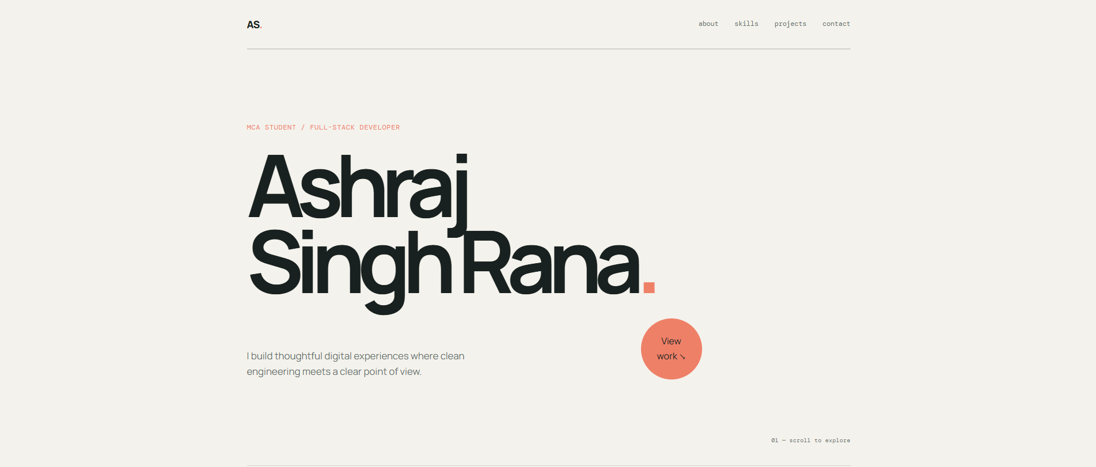
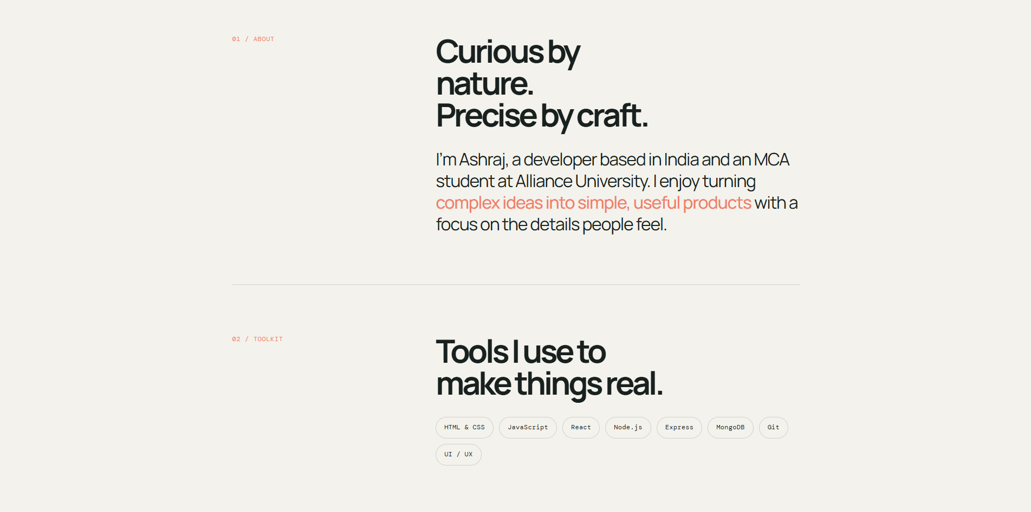
OUTPUT

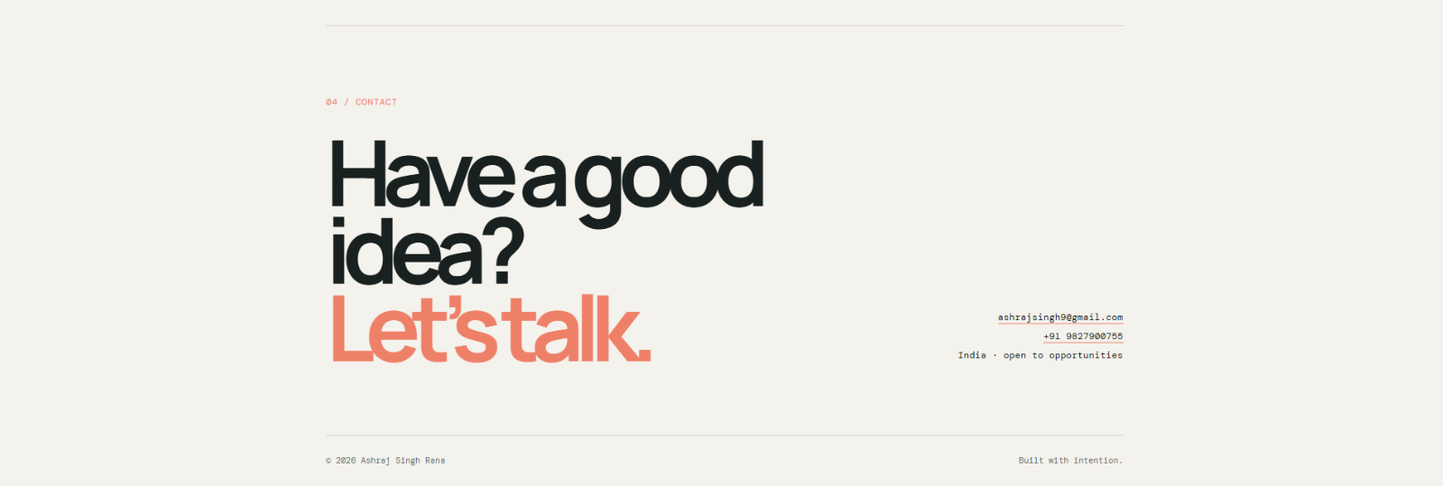
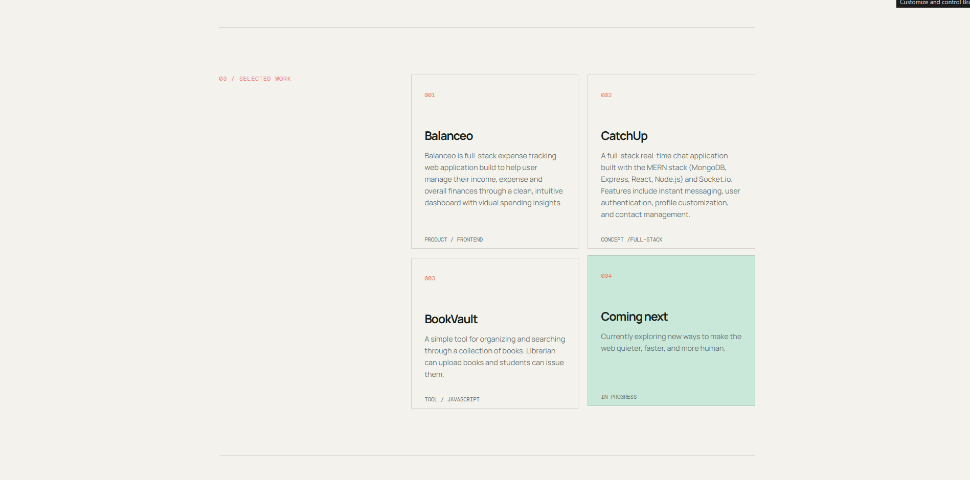
CONCLUSION
The Personal Portfolio Website successfully demonstrates the use of HTML and CSS to develop a structured, responsive, and professional web interface. The project provides an organized presentation of personal details, education, skills, services, projects, and contact information. CSS styling, grid layouts, flexbox, hover effects, color schemes, cards, and responsive media queries enhance the overall appearance and usability of the website. Through this project, fundamental front-end development concepts such as webpage structure, styling, layout design, responsiveness, and user-friendly navigation were practically implemented. Overall, the project provides a simple and effective digital platform to present professional and academic information online.

